MIND STORM SOFTWARE PVT LTD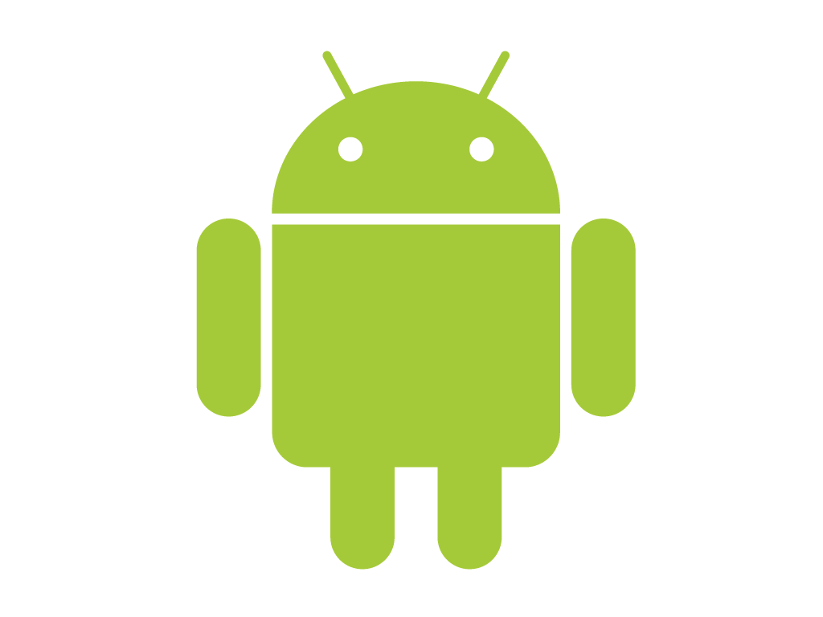
Hands-On Exercise – ex02.doc
Objective
Basic UI in Android and View Handlers
Assumptions
- Development Environment for Android (Java SDK, Eclipse, Android SDK) has been setup successfully.
- You are familiar with using Eclipse.
- Android SDK 2.3.3 is available and Android Virtual Devices are already created.
- Start the Android Virtual Device to save time.
  - Click on Window → Android SDK and AVD Manager.
  - Select an Android 2.3.3 compatible AVD and click on Start
  - Select Scale display to real size and provide a Screen Size (in) as 5 inches or any other appropriate size for your development machine.
Step by Step Instructions
Step 1 – Create the Android Project
- Create a new project. Click on File→New → Android Project
- Enter Project Name as ex02. Click on Next.
- Select the Build Target as Android 2.3.3. Click on Next.
- Enter Package Name as com.mindstorm.ex02
- In Create Activity, overwrite the default Activity name with the following name : MainActivity
- Click on Finish
- (Optional): Verify that the Project runs in your Emulator by Right-click the Project and Run As → Android Application
Step 2 – Code the Main Activity
- First we will add some strings to the resources which will be references in the activities. Go to res/values folder and modify strings.xml to contain the following:
<?xml version="1.0" encoding="utf-8"?>
<resources>
<string name="app_name">Famous Quotes</string>
<string name="app_title">Quotes App</string>
</resources>

- Define the Layout for MainActivity. This will consist of an image, a text field and 3 buttons, which will be clicked to get the next quote, send quote via SMS and send quote via Email respectively.
Go to res/layout, modify the main.xml file (You can simply copy this):
<?xml version="1.0" encoding="utf-8"?>
<LinearLayout xmlns:android="http://schemas.android.com/apk/res/android"
android:orientation="vertical"
android:layout_width="fill_parent"
android:layout_height="fill_parent"
>

<ImageView
android:id="@+id/imageView1"
android:layout_width="wrap_content"
android:layout_height="wrap_content"
android:src="@drawable/app_header_image" />

<TextView
android:id="@+id/txtQuote"
android:layout_width="match_parent"
android:layout_height="wrap_content"
android:text="Sample Quote by Someone"
android:textAppearance="?android:attr/textAppearanceLarge" />

<Button android:text="Next"
android:id="@+id/btnNext"
android:layout_width="match_parent"
android:layout_height="wrap_content"/>
<Button android:text="SMS"
android:id="@+id/btnSMS"
android:layout_width="match_parent"
android:layout_height="wrap_content"/>
<Button android:text="Email"
android:id="@+id/btnEmail"
android:layout_width="match_parent"
android:layout_height="wrap_content"/>
</LinearLayout>

In the graphical view of the layout, it should look something like shown below. You can select any image you want for the <ImageView>.
If you wish to use the default image, there is one provided with the hands-on exercises. The file name is app_header_image.png and you should copy this file to the res\drawable-hdpi folder.
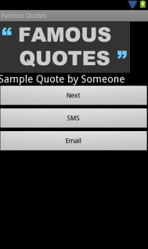
- Go to src → com.mindstorm.ex02 and open MainActivity.java file
The code to be placed is shown below:
package com.mindstorm.ex02;

import android.app.Activity;
import android.os.Bundle;
import android.view.View;
import android.view.View.OnClickListener;
import android.widget.Button;
import android.widget.Toast;

public class MainActivity extends Activity {
/** Called when the activity is first created. */
@Override
public void onCreate(Bundle savedInstanceState) {
super.onCreate(savedInstanceState);
setContentView(R.layout.main);

//Next Button
Button btnNext = (Button)findViewById(R.id.btnNext);
btnNext.setOnClickListener(new OnClickListener() {

@Override
public void onClick(View v) {
showToast("Get Next Quote");
}
});

//SMS Quote Button
Button btnSMS = (Button)findViewById(R.id.btnSMS);
btnSMS.setOnClickListener(new OnClickListener() {

@Override
public void onClick(View v) {
showToast("Launch SMS App");
}
});

//Email Quote Button
Button btnEmail = (Button)findViewById(R.id.btnEmail);
btnEmail.setOnClickListener(new OnClickListener() {

@Override
public void onClick(View v) {
showToast("Launch Email App");
}
});

}
private void showToast(String msg) {
Toast.makeText(this, msg, Toast.LENGTH_SHORT).show();
}
}
Step 3 – Run the Example
- Right Click the Project in Eclipse.
- Select Run As → Android Application
- (Optional): If you have multiple compatible AVDs running, select the correct AVD. In our case it is the 2.3.3 AVD.

You should see the MainActivity screen come up as shown below:
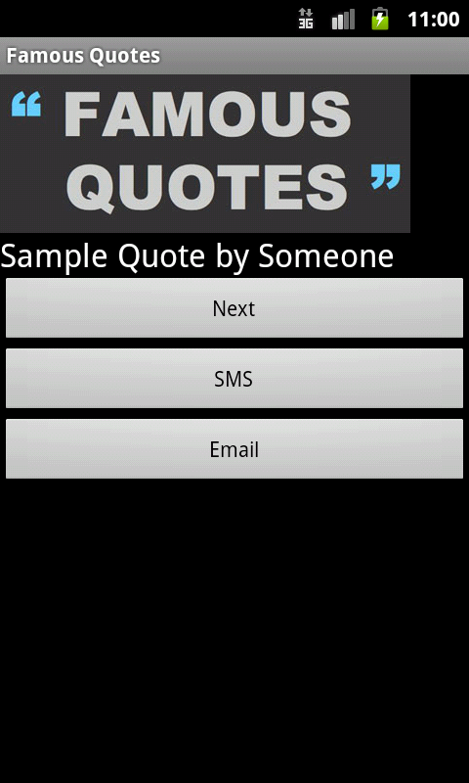

On clicking the Begin button, you should see the respective button click handlers getting fired. Currently they only show Toast messages.
Summary
This hands-on exercise demonstrated how you can use the Linear Layout to create the UI for an Android activity. The Layout can have multiple views within it. Event Handlers are written on the views so that the code that needs to be executed when the view is clicked (for example) is executed.

